1. Variable summaries
   1. summary(PAR)

Min. 1st Qu. Median Mean 3rd Qu. Max. NA's

0.00 22.00 38.25 41.41 59.58 100.00 20

* 1. summary(SPI)

Min. 1st Qu. Median Mean 3rd Qu. Max. NA's

0.00 26.88 51.60 49.84 71.95 100.00 2

1. Variable Boxplots
   1. 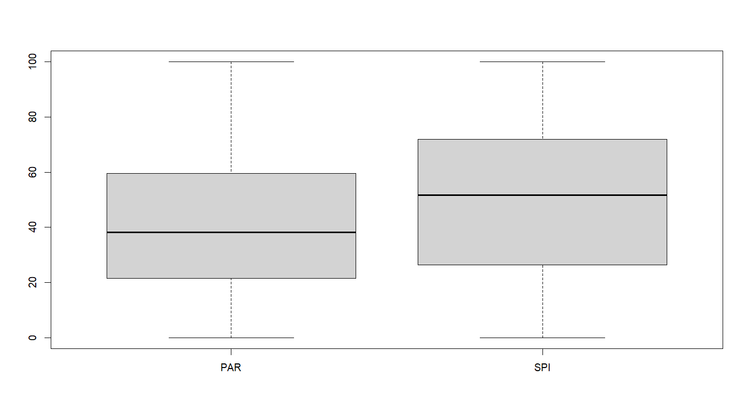
2. Histograms with overlayed theoretical probability distributions
   1. 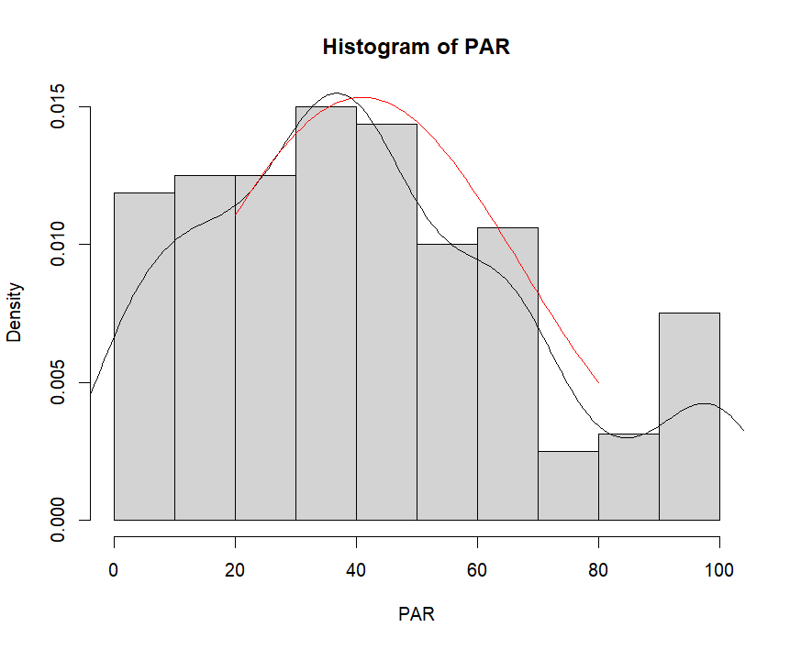
   2. 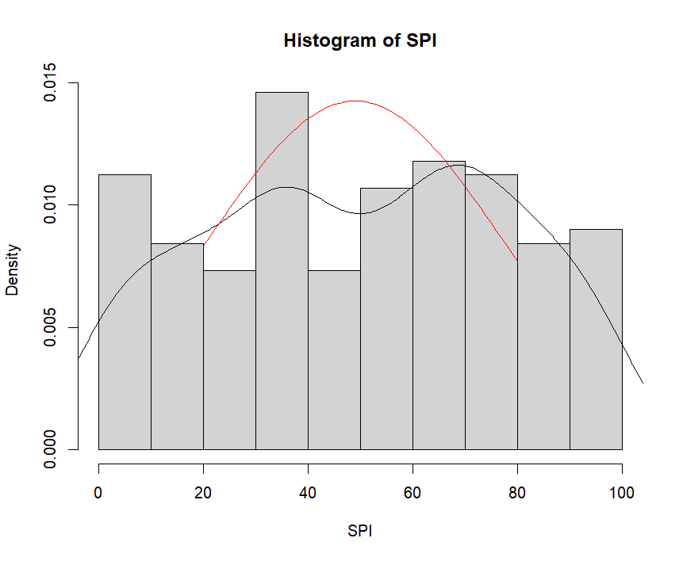
3. ECDF plots
   1. 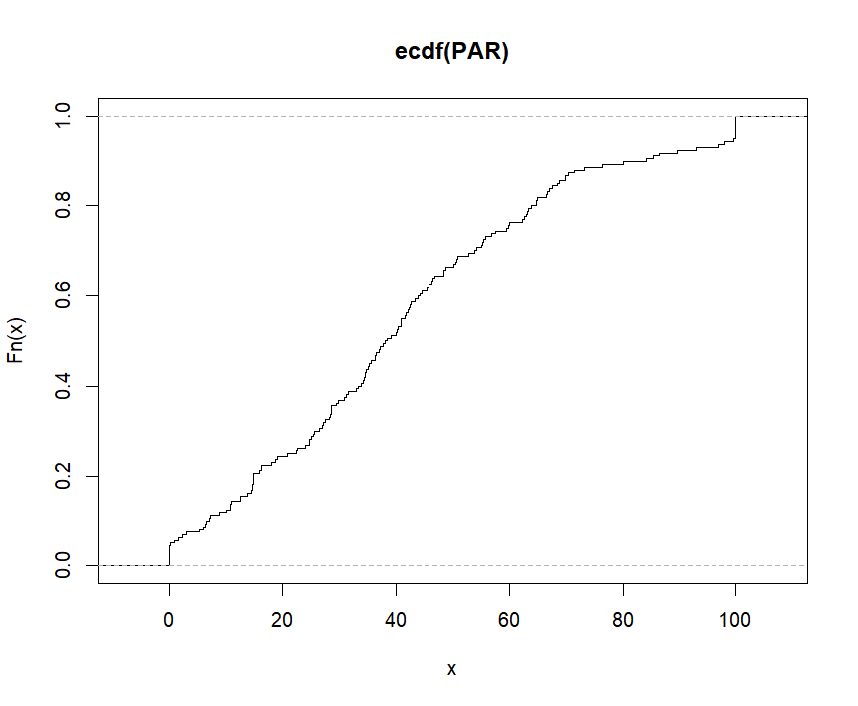
   2. 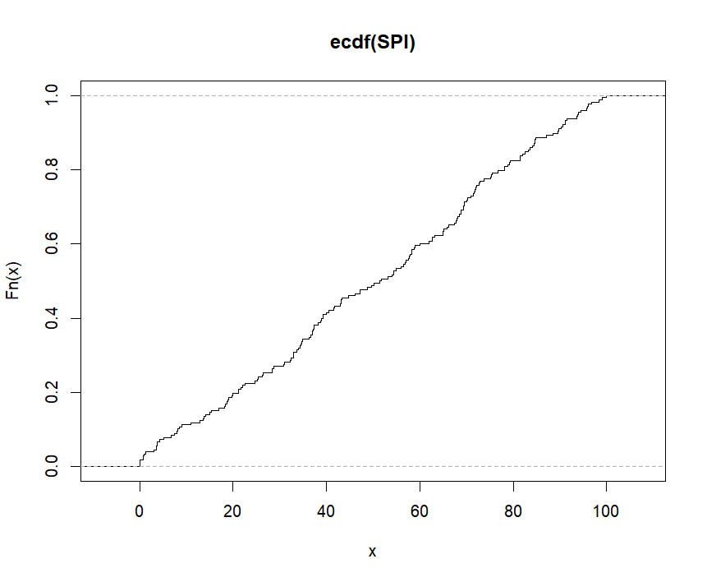
4. QQ plots of each variable against the normal distribution
   1. 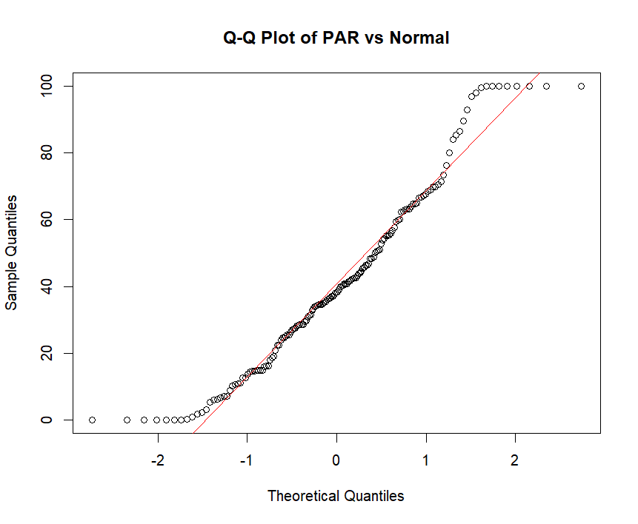
   2. 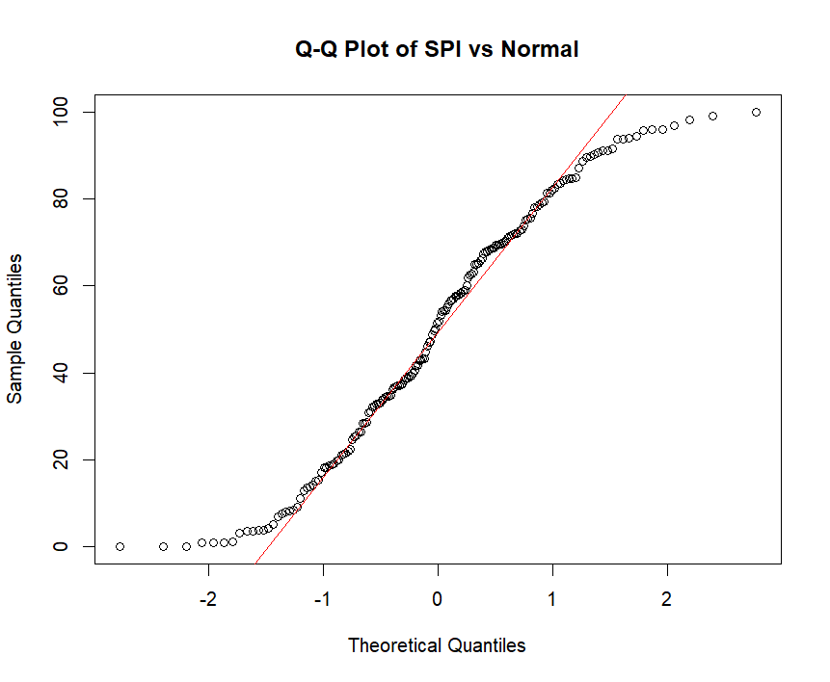
5. QQ plot of the 2 variables against each other
   1. 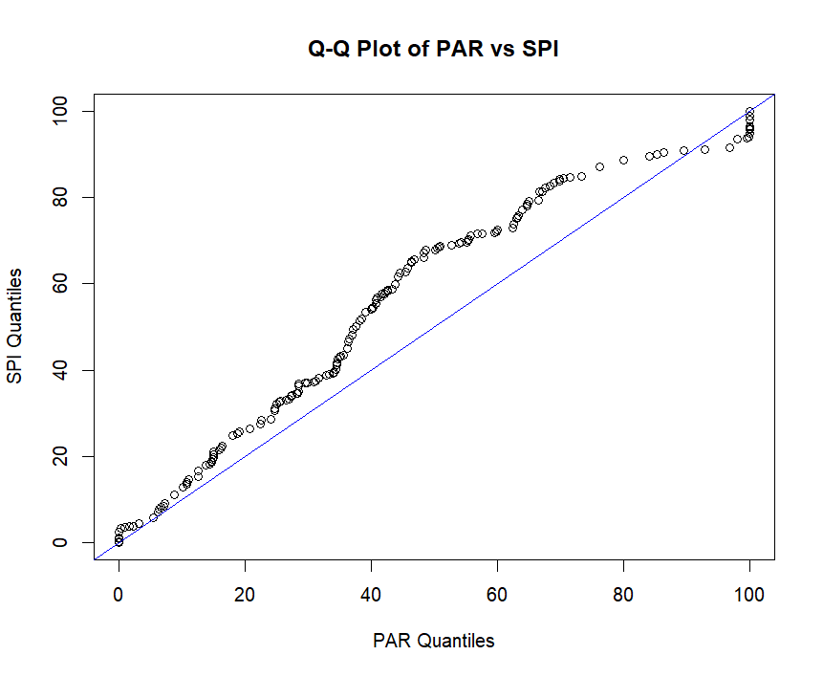
6. Normality statistical tests for each variable
   1. shapiro.test(PAR)
      1. Shapiro-Wilk normality test
      2. data: PAR
      3. W = 0.95572, p-value = 5.779e-05
         1. Fail to reject the null hypothesis because our p-value is greater than 0.05.
   2. shapiro.test(SPI)
      1. Shapiro-Wilk normality test
      2. data: SPI
      3. W = 0.95998, p-value = 5.774e-05
         1. Fail to reject the null hypothesis because our p-value is greater than 0.05.
   3. ad.test(PAR)
      1. Anderson-Darling normality test
      2. data: PAR
      3. A = 1.4178, p-value = 0.001112
         1. Fail to reject the null hypothesis because our p-value is greater than 0.05.
   4. ad.test(SPI)
      1. Anderson-Darling normality test
      2. data: SPI
      3. A = 1.7105, p-value = 0.0002121
         1. Fail to reject the null hypothesis because our p-value is greater than 0.05.
7. Statistical test for the variables having identical distributions
   1. ks.test(PAR,SPI)
      1. Asymptotic two-sample Kolmogorov-Smirnov test
      2. data: PAR and SPI
      3. D = 0.19754, p-value = 0.002786
         1. Fail to reject the null hypothesis because our p-value is greater than 0.05.
      4. alternative hypothesis: two-sided
   2. wilcox.test(PAR,SPI)
      1. Wilcoxon rank sum test with continuity correction
      2. data: PAR and SPI
      3. W = 11686, p-value = 0.004407
         1. Fail to reject the null hypothesis because our p-value is greater than 0.05.
      4. alternative hypothesis: true location shift is not equal to 0
   3. var.test(PAR,SPI)
      1. F test to compare two variances
      2. data: PAR and SPI
      3. F = 0.90111, num df = 159, denom df = 177, p-value = 0.5033
      4. alternative hypothesis: true ratio of variances is not equal to 1
      5. 95 percent confidence interval:v 0.6657964 1.2226579
      6. sample estimates:
      7. ratio of variances: 0.9011128
   4. t.test(PAR,SPI)
      1. Welch Two Sample t-test
      2. data: PAR and SPI
      3. t = -2.7981, df = 334.99, p-value = 0.005438
      4. alternative hypothesis: true difference in means is not equal to 0
      5. 95 percent confidence interval: -14.358256 -2.504019
      6. sample estimates:
      7. mean of x mean of y : 41.40875 49.83989